**LINUX ASSIGNMENT**

1. Answers related to first questions

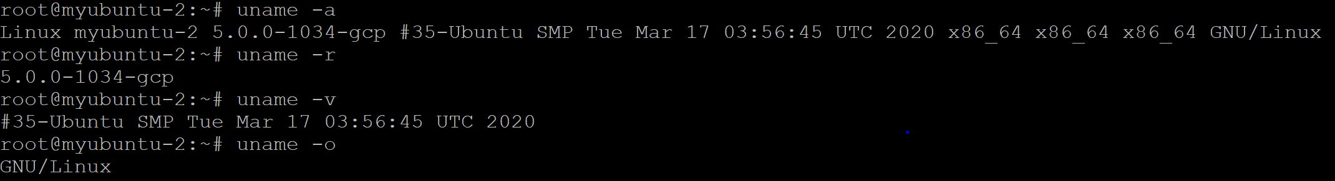

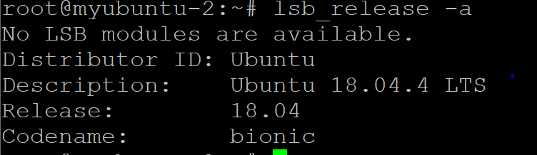

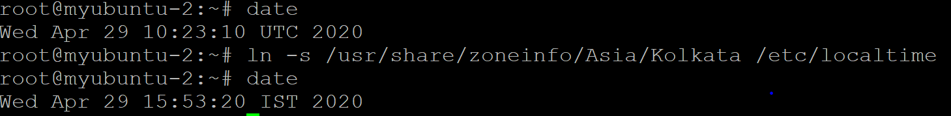

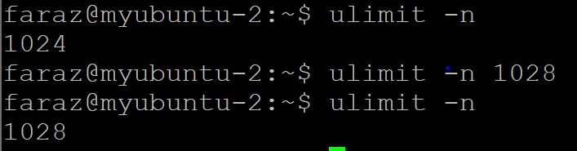

1. Edit default config for nginx

sudo vim /etc/nginx/sites-available/default

Add following to config section: location /myfolder { # new url path alias /home/username/myfolder/; # directory to list autoindex on; }

Create folder and sample file there:

mkdir -p /home/username/myfolder/ ls -la >/home/username/myfolder/mytestfile.txt

Restart nginx :- sudo systemctl restart nginx

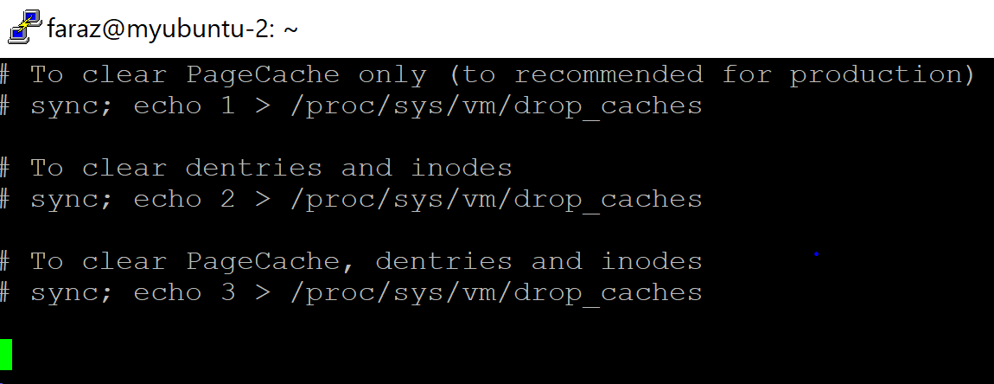

1. Inside /etc/crontab need to add below line



1. Add ‘date’ and ‘cal’ below in .bashrc file

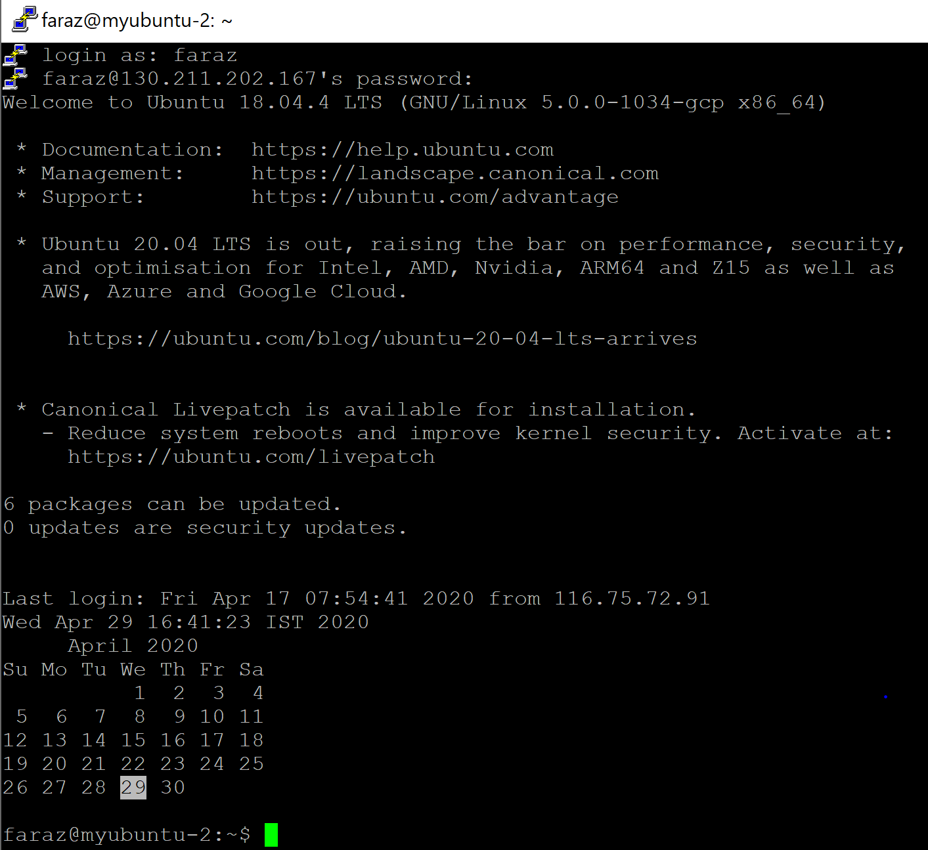

1. Useradd -m faraz  
   passwd faraz  
   add below line in visudo file  
   faraz ALL=(ALL:ALL) /usr/bin/rm
2. .bash_history is the file in which all history of the commands and we can delete the content of it.